Phase Plots

The Period Analysis section details how VStar can be used to analyze a dataset for candidate periods (the time taken for a star’s variability to complete one full cycle). If a star is assumed to have a particular period, VStar can be asked to create a so-called phase plot or folded light curve, in which all observations are plotted into a “window” of a particular size: the period in days.
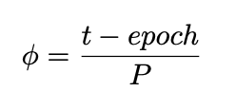
To accomplish this, each observation’s time is converted to a phase according to the following equation:

where ϕ is the phase, t is the observation time, epoch is some initial time, and P is the assumed period. The epoch can be one of a number of values from the current dataset, such as the time of the first observation, the time closest to the mid-point, the mean of the first and last time, a time of minimum or maximum. The most appropriate epoch to use may depend upon the variable type. If one is not available from VSX for the star (and only for an AID loaded dataset), the default epoch computed by VStar is the mean of the first and last time in the current dataset.

Assume the following eta Aquilae dataset is loaded:

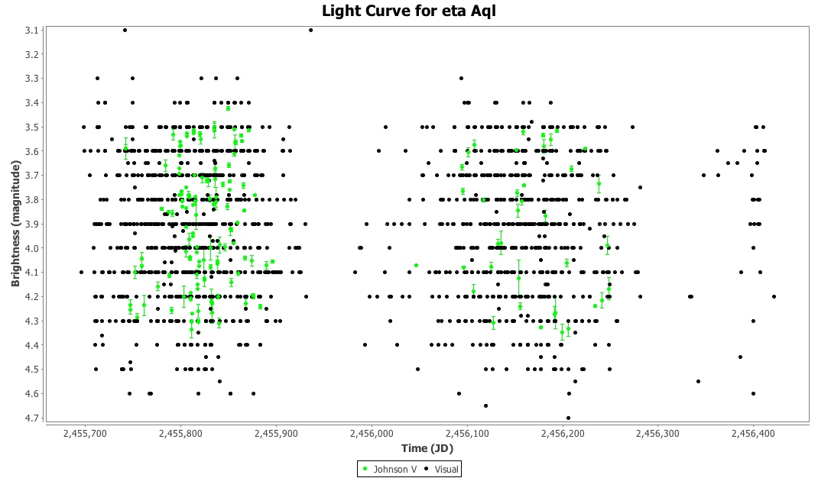

Using the period and epoch for eta Aquilae shown on VSX (http://www.aavso.org/vsx/index.php?view=detail.top&oid=2802), the following phase plot can be created.

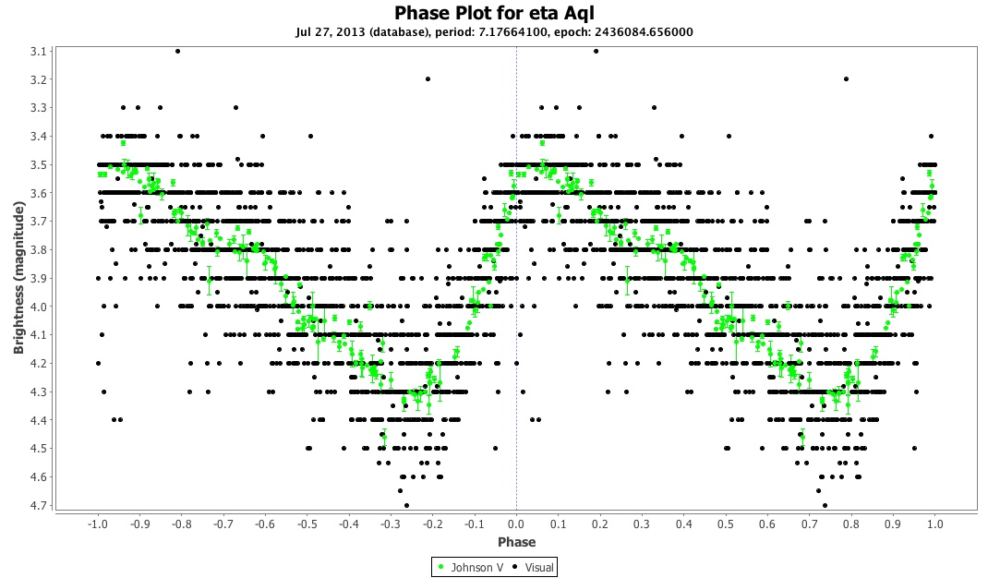

To create a phase plot like this one, select Analysis → Phase Plot...

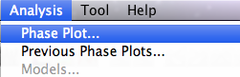

yielding the phase plot parameter dialog and click OK to create the phase plot:
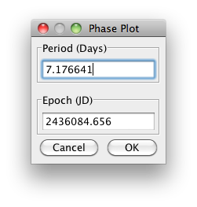
If a dataset is loaded from AID, VStar will retrieve this information from VSX and populate the phase plot parameter dialog text fields.

A phase plot for which the specified period is incorrect compared to the actual period, results in a “messy” (or out of phase) plot. For example, here is eta Aquilae with a phase plot using a period of 7.5 days instead of 7.176641 days:

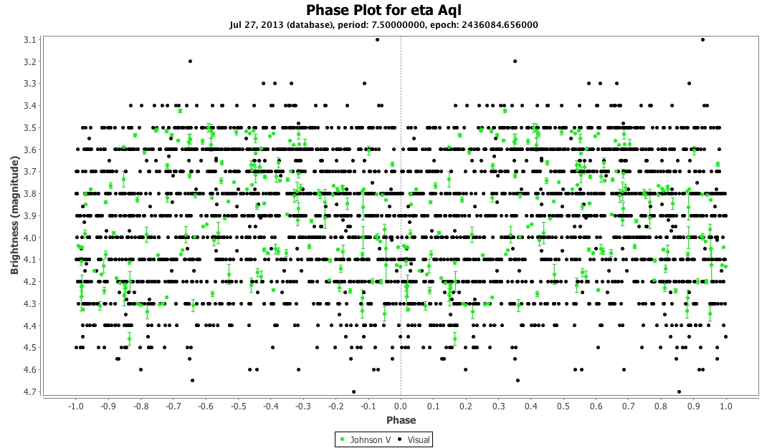

The Analysis menu’s Previous Phase Plots... item yields a dialog that permits previously created phase plots to be selected or deleted, e.g.
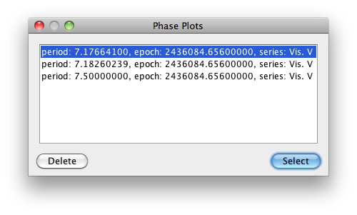

The first two items in the View menu allow you to switch between phase plot and raw view modes. There are corresponding toolbar buttons.

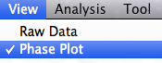

If no phase plot exists the first time Phase Plot view mode is selected, the phase plot parameter dialog will be invoked.

Here is another example that demonstrates the visualization power of a phase plot given the right period. The following shows a V0838 Cyg dataset loaded via the Kepler observation source plug-in.

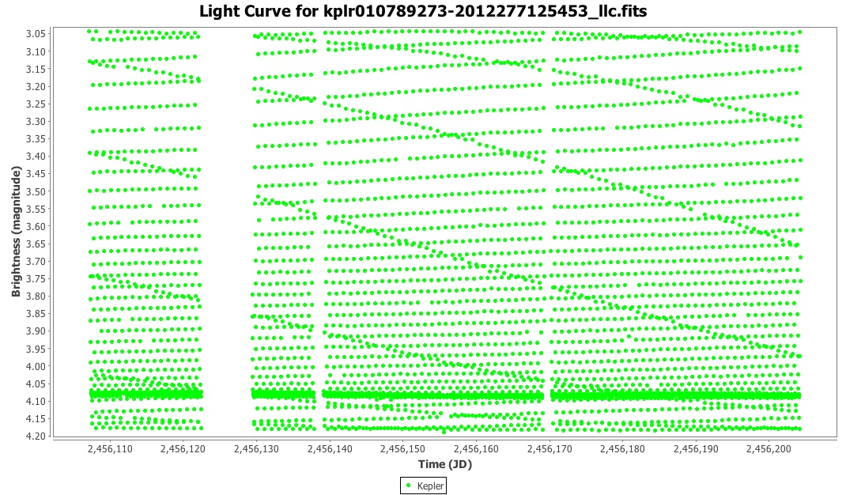

As described in detail elsewhere (http://dbenn.wordpress.com/2013/03/29/obtaining-and-analysing-kepler-data-with-vstar), the following phase plot reveals the nature of the star as an RR Lyr star variable (RRAB) with a period of around 0.48 days.

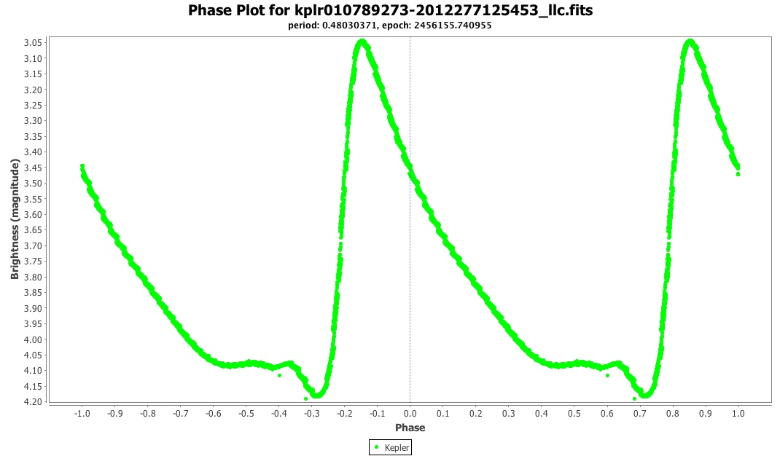

The observation list is also affected when phase plot mode is enabled: a phase column is added, e.g.

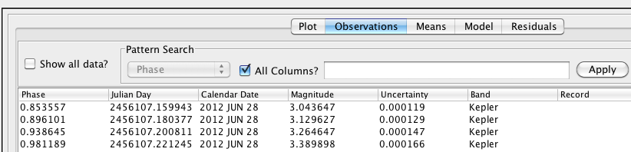

By default, observation rows are still sorted by JD, but clicking the Phase column will order by phase.

The Period Analysis section shows how to create a phase plot from the result dialog of a period search. See also the Further Reading section.

